**UNIT – III**

**SECONDARY SEWAGE TREATMENT**

**Principles and Nutritional Requirements of Biological Treatment System:**

Secondary treatment of the wastewater could be achieved by chemical unit processes such as chemical oxidation, coagulation-flocculation and sedimentation, chemical precipitation, etc. or by employing biological processes (aerobic or anaerobic) where bacteria are used as a catalyst for removal of pollutant. For removal of organic matter from the wastewater, biological treatment processes are commonly used all over the world. Hence, for the treatment of wastewater like sewage and many of the agro-based industries and food processing industrial wastewaters the secondary treatment will invariably consist of a biological reactor either in single stage or in multi stage as per the requirements to meet the discharge norms.

# Biological Treatment:

The objective of the biological treatment of wastewater is to remove organic matter from the wastewater which is present in soluble and colloidal form or to remove nutrients such as nitrogen and phosphorous from the wastewater. The microorganisms (principally bacteria) are used to convert the colloidal and dissolved carbonaceous organic matter into various gases and into cell tissue. Cell tissue having high specific gravity than water can be removed in settling tank. Hence, complete treatment of the wastewater will not be achieved unless the cell tissues are removed. Biological removal of degradable organics involves a sequence of steps including mass transfer, adsorption, absorption and biochemical enzymatic reactions. Stabilization of organic substances by microorganisms in a natural aquatic environment or in a controlled environment of biological treatment systems is accomplished by two distinct metabolic processes: respiration and synthesis, also called as catabolism and anabolism, respectively.

**Respiration:** A portion of the available organic or inorganic substrate is oxidized by the biochemical reactions, being catalyzed by large protein molecules known as enzymes produced by microorganism to liberate energy. The oxidation or dehydrogenation can takes place both in aerobic and anaerobic conditions. Under aerobic conditions, the oxygen acts as the final electron acceptor for the oxidation. Under anaerobic conditions sulphates, nitrates, nitrites, carbon dioxide and organic compounds acts as an electron acceptor. Metabolic end products of the respiration are true inorganics like CO2, water, ammonia, and H2S.

The energy derived from the respiration is utilized by the microorganisms to synthesize new protoplasm through another set of enzyme catalyzed reactions, from the remaining portion of the substrate. The heterotrophic microorganisms derive the energy required for cell synthesis exclusively through oxidation of organic matter and autotrophic microorganisms derive the energy for synthesis either from the inorganic substances or from photosynthesis.

The energy is also required by the microorganisms for maintenance of their life activities. In the absence of any suitable external substrate, the microorganisms derive this energy through the oxidation of their own protoplasm. Such a process is known as **endogenous respiration** (or decay)**.** The metabolic end products of the endogenous respiration are same as that in primary respiration.

The metabolic processes in both aerobic and anaerobic processes are almost similar, the yield of energy in an aerobic process, using oxygen as electron acceptor, is much higher than in anaerobic condition. This is the reason why the aerobic systems liberates more energy and thus produce more new cells than the anaerobic systems.

***Catabolism and Anabolism:*** The most important mechanism for the removal of organic material in biological wastewater treatment system is by bacterial metabolism. Metabolism refers to the utilization of the organic material, either as a source of energy or as a source for the synthesis of cellular matter. When organic material is used as an energy source, it is transferred into stable end products, a process known as *catabolism*. In the process of *anabolism* the organic material is transformed and incorporated into cell mass. Anabolism is an energy consuming process and it is only possible if catabolism occurs at the same time to supply the energy needed for the synthesis of the cellular matter. Thus, the processes of catabolism and anabolism are interdependent and occur simultaneously.

**Principles of Biological Wastewater Treatment:**

Under proper environmental conditions, the soluble organic substances of the wastewater are completely destroyed by biological oxidation; part of it is oxidized while rest is converted into biological mass, in the biological reactors. The end products of the metabolisms are either gas or liquid; and on the other hand the synthesized biological mass can flocculate easily and it can be easily separated out in clarifiers. Therefore, the biological treatment system usually consists of (1) a biological reactor, and (2) a sedimentation tank, to remove the produced biomass called as sludge.

The growth of microorganisms and the rate at which the substrate will be utilized with respect to time will depend on the type of the reactor employed and environmental conditions. This can be represented for batch process (Figure: 1) and continuous process (Figure: 2) differently.

1. **Batch Process**

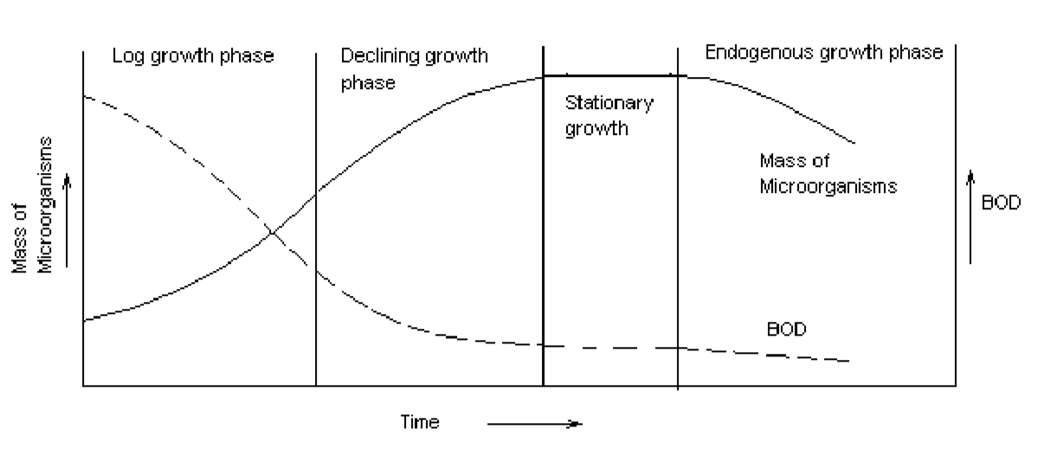

Figure:1 Growth of microorganisms under batch process

During fresh commissioning of the reactor if the microorganisms inoculated in the reactor are not adapted (acclimatized) to the type of wastewater being treated, there may be some ***lag phase***. During this phase there will be some lag time before the substrate is being accepted by the microbes, hence to reflect in substrate depletion and microbial growth.

***Log growth phase:*** Substrate is adequate in this phase and rate of metabolism is only dependent on the ability of microorganism to utilize the substrate.

***Declining growth phase:*** The rate of metabolism and hence growth rate of microorganisms decreases due to limitations of substrate supply. This is referred as substrate limited growth condition where substrate available is not enough to support maximum growth rate of microorganisms.

***Stationary phase:*** When the bacterial growth rate and decay rate are same there will be no net increase or decrease in mass of microorganism. This phase is referred as stationary phase. ***Endogenous growth phase:*** The microorganisms oxidize their own protoplasm for energy (endogenous respiration) and thereby decrease in number and mass.

## Continuous System

In continuous system ‘Food to Microorganism” ratio (F/M) controls the rate of metabolism. For low F/M: Food available is lower hence, it is endogenous growth of microorganisms (Figure: 2). For high F/M: Food available is abundant; hence the growth phase is log growth phase. In between the growth rate will be declined growth phase. The biological reactors are typically operated at declining growth phase or endogenous growth phase with sufficient F/M ratio so that the microorganisms mass is at least constant, and not depleting. The sludge produced at log phase is of very poor in settling characteristics and the sludge produced in the endogenous phase has better settling properties and settles well and is more stable.

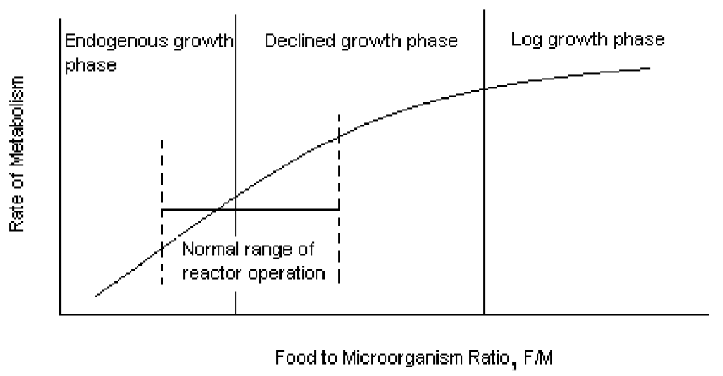

Figure: 2 Rate of metabolism in continuous reactors for different F/M ratio

# Nutritional Requirements For Microbial Growth:

For reproduction and proper functioning of an organism it must have

1. Source of energy
2. Carbon for the synthesis of new cellular material
3. Nutrients such as N, P, K, S, Fe, Ca, Mg, etc.

Energy needed for the cell synthesis may be supplied by light or by chemical oxidation reaction catalyzed by the bacteria. Accordingly the microbes can be classified as:

***Phototrophs:*** Organisms those are able to use light as an energy source. These may be heterotrophic (certain sulphur reducing bacteria) or autotrophic (photosynthetic bacteria and algae).

***Chemotrophs:*** Organisms that derive their energy from chemical reaction. These may be either heterotrophic, those derive energy from organic matter like protozoa, fungi, and most bacteria or may be autotrophic like nitrifying bacteria. Accordingly they are called as Chemoheterotrophs (those derive energy from oxidation of organic compounds) and chemoautotrophs (those obtain energy from oxidation of reduced inorganic compounds such as ammonia, nitrite, sulphide).

***Source of Carbon****:* The source of carbon for synthesis of new cell could be organic matter (used by heterotrophs) or carbon dioxide (used by autotrophs).

***Nutrient and growth factor requirement:*** The principal inorganic nutrients required by microorganisms are N, S, P, K, Mg, Ca, Fe, Na, Cl, etc. Some of the nutrients are required in trace amount (very small amount) such as, Zn, Mn, Mo, Se, Co, Ni, Cu, etc. In addition to inorganic nutrients, organic nutrients may also be required by some organisms and they are known as ‘growth factors’. These are compounds needed by an organism as precursors or constituents of organic cell material that cannot be synthesized from other carbon sources. Requirements of these nutrients differ from organism to organism. For aerobic processes generally minimum COD:N:P ratio of 100:10:1-5 is maintained. In case of anaerobic treatment minimum COD:N:P ratio of 350:5:1 is considered essential. The nutrient requirement is lower for anaerobic process due to lower growth rate of microorganisms as compared to aerobic process. While treating sewage external macro (N, P, K, S) and micro (trace metals) nutrients addition is not necessary; however incase of industrial effluent treatment, external addition of these may be required depending upon the characteristics of the wastewater.

**Types of Microbial Metabolism:**

***Aerobic microorganisms:*** When molecular oxygen is used as terminal electron acceptor in respiratory metabolism it is referred as aerobic respiration. The organisms that exist only when there is molecular oxygen supply are called as obligately aerobic.

***Anoxic microorganisms***: For some respiratory microorganisms oxidized inorganic compounds such as sulphate, nitrate and nitrite can function as electron acceptors in absence of molecular oxygen; these are called as anoxic microorganisms.

***Obligately anaerobic:*** These are the microorganisms those generate energy by fermentation and can exist in absence of oxygen.

***Facultative anaerobes:*** These microorganisms have ability to grow in absence or presence of oxygen. These can be divided in two types: (a) *True facultative anaerobes*: those can shift from fermentative to aerobic respiratory metabolism, depending on oxygen available or not; (b) *Aerotolerant anaerobes*: these follow strictly fermentative metabolism and are insensitive if oxygen is present in the system.

# Types of Biological Reactors

Depending upon availability of oxygen or other terminal electron acceptor the biological reactors are classified as aerobic, anaerobic, anoxic or facultative process. Depending on how the bacteria are growing in the reactors they can be classified as (a) suspended growth process: where bacteria are grown in suspension in the reactor without providing any media support such as activated sludge process, and (b) attached growth process: where microorganism growth occurs as a biofilm formed on the media surface provided in the reactor such as trickling filters. This media could be made from rocks or synthetic plastic media offering very high surface area per unit volume. The media could be stationary in the reactor, as in trickling filter, which is called as fixed film reactor or it could be moving media as used in moving bed bioreactor (MBBR). Hybrid reactors are becoming popular these days which employ both suspended growth as well as attached growth in the reactor to improve biomass retention and substrate removal kinetics such as submerged aerobic filters (SAF).

**FACTORS AFFECTING BIOLOGICAL TREATMENT:**

1. Suitability of waste
2. Form of waste
3. pH
4. Temperature

**WORKING PRINCIPLES AND CONSTRUCTIONAL DETAILS OF TRICKLING FILTER:**

**Trickling Filter:**

* Trickling filter is an ***attached growth process*** i.e. process in which microorganisms responsible for treatment are attached to an inert packing material. Packing material used in attached growth processes include rock, gravel, slag, sand, redwood, and a wide range of plastic and other synthetic materials.

**Process Description**

* The wastewater in trickling filter is distributed over the top area of a vessel containing non-submerged packing material.
* Air circulation in the void space, by either natural draft or blowers, provides oxygen for the microorganisms growing as an attached biofilm.
* During operation, the organic material present in the wastewater is metabolised by the biomass attached to the medium. The biological slime grows in thickness as the organic matter abstracted from the flowing wastewater is synthesized into new cellular material.
* The thickness of the aerobic layer is limited by the depth of penetration of oxygen into the microbial layer.
* The micro-organisms near the medium face enter the endogenous phase as the substrate is metabolised before it can reach the micro-organisms near the medium face as a result of increased thickness of the slime layer and loose their ability to cling to the media surface. The liquid then washes the slime off the medium and a new slime layer starts to grow. This phenomenon of losing the slime layer is called ***sloughing***.
* The sloughed off film and treated wastewater are collected by an underdrainage which also allows circulation of air through filter. The collected liquid is passed to a settling tank used for solid- liquid separation.
* Trickling filters are of two types:

1. Low rate TF
2. High rate TF



**Loading, efficiency and performance of conventional TFs:**

1. **Loading:**
2. **Hydraulic loading:** 25 to 40 million litres per hectare of surface per day

7.5 to 22.5 million litres per hectare of filter volume per day.

1. **Organic loading:** 1000 to 2200 kg BOD per hectare metre of filter volume per day.
2. **Efficiency:**

**E (%) = $\frac{100}{1+0.0044\sqrt{u}}$**

**E = $\frac{100}{1+0.44\sqrt{U}}$**

E = Efficiency of the filter (%)

u = organic loading in kg/m3/day

U = hydraulic loading in kg/m3/day

**High Rate TF:**

The basic difference between high rate or conventional trickling filter is that the rate of filter loading the former is more than that of latter. The main defect of the conventional trickling fllter is that it has high initial cost, it requires larger area of construction and it requires large quantity of filtering media.

Experiments conducted on trickling filters with increasing rate of sewage flow revealed the following:

1. As the sewage flow is increased, the thickness of the gelatinous biofilm is reduced and the organic materials deposited on the contact surface is continuously washed

2. Thinner bio-film is more efficient and supplies more continuous nutrients to the aerobic bacteria.

3. The precipitation and biological coagulation of the dissolved and colloidal matter is more or less of the same degree as in normal rate filters.

4. However, there is lesser oxidation of organic matter because of reduction in the contact period.

5. Since large quantity of unloaded putrescible organic material reaches the secondary settling tank, the load on the secondary settling tank is increased.

6. The sludge produced as a result of high rate filtration is not easily digestible.

7. The cost of construction and land etc. decreases with the increase in rate of filtration.

Due to the above favourable observations, high rate trickling filters have become more popular and they have replaced conventional trickling filters in many countries

To achieve high rate filtration, the following modifications are made to the conventional or slow rate trickling filters.

1. Better quality filtering materials are used, so as to give higher specific surface. The recent trend is towards the use of larger size stone media, or to use plastic synthetic media.
2. The depth of filter media is reduced to about 1.5 to 2.0 m, so as to obtain better aeration in order to obtain high rate of biological activity.
3. The size of under-drains is increased and their slope is also made steeper so that the filter effluent can be collected and conveyed to the secondary settling tank quickly.
4. The speed of radiation of the rotating arm is increased to 2 rpm for increased hydraulic loading.
5. The size of secondary settling tank is also correspondingly increased to cope with the increased quantity of flow and bio-flocculent solids coming out with the trickling filter effluent.

**Recirculation**: Recirculation consists in returning a portion of the treated or partly treated sewage to the treatment process. Recirculation is necessary to provide uniform hydraulic loading as well as to dilute the high strength wastewaters. In contrast to the low rate filters, in high rate filters a part of settled or filter effluent is recycled through the filter.

**Single and two stage plants:** A single stage plant is the one, in which the sewage is passed through single filter, if there are two or more filters, they are operated parallel. Sewage may be, and usually is, recirculated to single stage filters. Two stage filters consists of two filters in series with primary settling tank, an intermediate settling tank which may be omitted in certain cases, and a final settling tank.

Recirculation facilities are provided for each stage. The effluent from first stage filter is applied to second stage either after settlement or without settlement. Two stage filtration will provide a higher degree of treatment than the single stage for the same total volume of media.

Two stage units are used for strong sewage when the effluent BOD has to be less than 30 mg/l. The same volume of medium is used for single stage and two stage plants. With two stages, however, the volume of filter medium is divided, usually equally, between the first-stage and second-stage units. After primary settling, the entire organic load is applied to the first-stage (or primary) filter, due to which the first-stage filter is a so-called roughing filter, the principal function of which is to remove BOD and prepare the sewage for treatment in the second-stage filter.

**Advantages of High Rate Trickling Filters:**

* Initial cost is low, filter volume required is low.
* Operating cost is low.
* Trouble of odour is much less.
* Absence of Trickling filters flies.
* Working is flexible. Efficiency of filter is not seriously affected due to variations in the strength and character of sewage.

**Diadvantages:**

* The effluent from the system requires more volume of dilution water.
* Raw sewage cannot be treated and the process requires primary treatment of sewage.

**Recirculation and TF Flow Sheets**

* Recirculation is the return of a portion of treated or partly treated sewage to the treatment process. Usually the return is the form the secondary settling tank to primary settling tank or to the dosing tank of the filter.
* Recirculation of sewage is an important factor in HRF. It is expressed in terms of recirculation ratio (R).

**Recirculation Ratio (R):**

* The ratio of recirculated flow to the flow of raw sewage is called recirculation ratio(R). This ratio determines the required capacity of recirculating pumps and the hydraulic load placed upon the filters.

Capacity of recirculating pump = R x ( influent sewage flow)

Hydraulic load of the filter = (1 + R ) x (influent sewage flow )

**Recirculation Factor:**

* The number of effective passages through the filter is known as recirculation factor (F)

F= $\frac{1+R}{[ 1+\left(1 -f\right)R]²}$ = $\frac{1+R}{(1+0.1R)²}$

Where R = treatability factor = (0.9 for sewage)

* Recirculation ratio usually range from 0.5 to 3 and values exceeding 3 are considered to be uneconomical in case of domestic sewage, but ratio of 8 and above have been used in industrial wastes.
* If the sewage has high concentration of 5 day BOD, it can be effectively used by passing it a number of times through the TFs.

**Process design and efficiencies:**

* Important considerations in HRTFs are organic loading and recirculation ratio.
* Filter depths are ordinarily about 2m in standard rock or dumped plastic media. Higher depths of 5m or even more may use with packed towers containing plastic sheets or red wood media.
* Plant efficiencies based on organic loading rates and recirculation ratios are determined by number of equations

1. **Rankin‘s Equations: (applicable to fig. ai and aii)**
2. **For single stage filters:**

Ci + R Ce = 3 (1 + R)Ce

(Ce) =

e = (Ci - Ce)/Ci

=

Where Ci = BOD of influent sewage after settling (mg/l)

R = Recirculation ratio

e = Efficiency of the filter

Ce = BOD of settled filter effluent ( mg/l)

* This equation is applicable only when the organic loading rate on the fliter, including recirculation, is less than 1800 g/d/m3 and the hydraulic loading, including recirculation is maintained between 10 to 30 m3/d/m2 when the organic loading ranges between 1800 to 2800 g/d/m3, the following equation is used:

Ce = Ci/( 2.78 + 1.78R )

This equation is applicable to flow diagram (aiii) and (bi)

1. **First stage of two stage filters (applied to fig. bii and biv)**

Ce = Ci/( 2 + R )

e = $\frac{1+R}{2+R}$

Loading limitations are same 2nd equation

In the first stage effluent consists partly of settled sewage, which does not pass through the first stage filter, such as shown in the flow diagram of Fig. biii, the following is used:

Ce = (1.5 + Ci) / (2.5 + r)

r = assumed recirculation given by

r = (Q1 - Q) / Q

* Q being the raw sewage flow to the plant and Q1 is the total flow through the first stage filter.
* The BOD loading on the filter is given by the following equations

La1 = Q ( Ci + R1Ce)

Where La1 = BOD5 loading in kg/day

Q = Sewage flow in MLD

1. **Second stage of two stage filter**

Applicable to bi, bii, biv

Ce + R’ Ce’ = 2(1+ R’) Ce’

Ce’ = Ce /(2 + R’)

e’ = (1+R’)/(2+R’)

where Ce’ = BOD of settled effluent from second stage (mg/l)

R’ = Recirculation ratio in the second stage filter

e’ = Efficiency of second stage filter

1. **NRC equations:**

These eqations are applicable both for low and high rate TFs. The efficiency of single stage filter or first stage of two stage filters is given by

**E (%) = $\frac{100}{1+0.44\sqrt{\frac{W}{VF}}}$**

**E = $\frac{100}{1+0.44\sqrt{U}}$**

For second stage of the two stage filters, efficiency is given by

**E′ (%) = $\frac{100}{1+\frac{0.44}{1-e}\sqrt{\frac{W'}{V'F'}}}$**

**E = $\frac{100}{1+\frac{0.44}{1-e}\sqrt{U}}$**

Where E = Removal Efficiency (%) in the single stage or first stage of the two stage filter

e = E/100

W = BOD loading rate in the single stage or first stage of the two stage filter

V = Volume of the first stage filter = m3

F = Recirculation factor

F= $\frac{1+R}{[ 1+\left(1 -f\right)R]²}$ = $\frac{1+R}{(1+0.1R)²}$

Where R = treatability factor = (0.9 for sewage)

**ACTIVATED SLUDGE PROCESS**

Activated sludge process is used during secondary treatment of wastewater. Activated sludge is a mixture of bacteria, fungi, protozoa and rotifers maintained in suspension by aeration and mixing.

In this process, a biomass of aerobic organisms is grown in large aerated basins. These organisms breakdown the waste and use it as their food to grow themselves. Activated sludge processes return settled sludge to the aeration basins in order to maintain the right amount of organisms to handle the incoming "food".

Activated sludge processes have removal efficiencies in the range (95-98%) than trickling filters (80-85%).

**WORKING OF ACTIVATED SLUDGE SYSTEM:**

* A primary settler (or primary clarifier) may be introduced to remove part of the suspended solids present in the influent and this reduces the organic load to the activated sludge system.
* The biological reactor or aeration tank is filled with a mixture of activated sludge and influent, known as “mixed liquor”. It is necessary to maintain certain mixed liquor suspended solid (MLSS) in the aerated tank maintain good removal efficiency.
* The aeration equipment transfers the oxygen necessary for the oxidation of organic material into the reactor, while simultaneously introducing enough turbulence to keep the sludge flocs in suspension.
* The continuous introduction of new influent results in a continuous discharge of mixed liquor to the secondary settler where separation of solids and liquid takes place.
* The liquid leaves the system as treated effluent, whereas some part of the sludge is recirculated to the aeration tank called as ‘return sludge’ and rest of sludge is taken for anaerobic digestion.

**DESIGNING OF ACTIVATED SLUDGE SYSTEM**

Suppose, Q is the flow rate of influent (m3/d), QW is the flow rate of waste sludge (m3/d), or is the flow rate of return activated sludge (m3/d), V is the volume of aeration tank (m3), S0 is the influent soluble substrate concentration (BOD g/m3), S is the effluent soluble substrate concentration (BOD g/m3), Xo is the concentration of biomass in influent (g VSS/m3), XR is the concentration of biomass in return line from clarifier (g VSS/m3), Xr is the concentration of biomass in sludge drain (g VSS/m3) and Xe is the concentration of biomass in effluent (g VSS/m3).

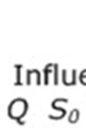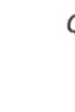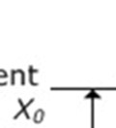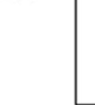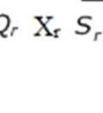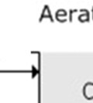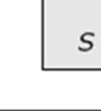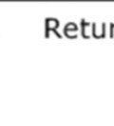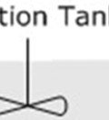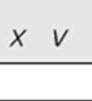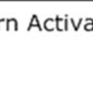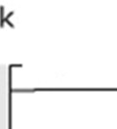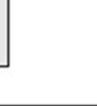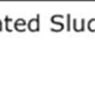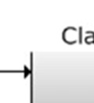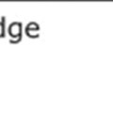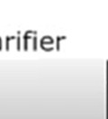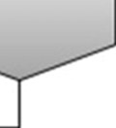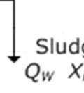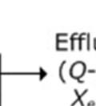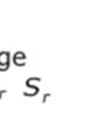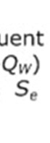

Fig: Activated Sludge Process

**Aeration tank loading criteria:**

Loading rates of aeration tank is based on the following four criteria:

1. **Hydraulic retention time (HRT) or aeration period:** The aeration period or loading rate express the rate at which sewage is applied in the aeration tank.

HRT (hrs) = $\frac{V}{Q ×1000} ×24$

V = Volume of aeration tank (m3)

Q = Sewage inflow (MLD)

1. **Volumetric BOD loading:** BOD5 applied per unit volume of aeration tank.

Volumetric load (kg BOD5 / m3) =

La = influent BOD (mg/l)

1. **Organic loading based on food to micro – organisms ratio:**

F/M = $\frac{Q ×L_{a}}{(V/1000)x_{t}}$

1. **Solids retention time or Mean cell residence time or sludge age:**

θc =

Where X = total microbial mass in a reactor

$∆X /∆t$ = total quantity of solids withdrawn daily, including solids deliberately wasted and those in the effluent.

**OXIDATION/STABILIZATION POND:**

* A stabilization pond (or lagoon) is an open, flow-through earthen basin of controlled shape, specifically designed and constructed to treat sewage and biodegradable industrial wastes.
* The term oxidation pond, often used, is synonymous. It is a relatively low-cost treatment system which has been widely used, particularly in rural areas. These ponds may be considered to be completely mixed biological reactors without solids return.
* The mixing is usually provided by natural processes (such as wind, heat, fermentation), but may be augmented by mechanical or diffused aeration. Stabilization ponds provide comparatively long detention periods extending from a few to several days when the putrescible organic matter in the waste gets stabilized by the action of natural forces.
* The design criteria for such low cost treatment systems have been evolved in our country. An extensive study conducted in our country has revealed that, under certain conditions, the degree of 'treatment that can be achieved is as good as that of the conventional system, if these low cost systems are adopted.

**Classification of stabilization ponds:**

1. Aerobic
2. Anaerobic or
3. Facultative (aerobic-anaerobic)

Each subtype mentioned above utilizes a different biological activity and is of similar basic construction, with an earthen pit of earthen side leeves. These are constructed in impervious soil, such as clay. If constructed in more permeable soil, they should be properly lined with impervious soil (clay) or with a synthetic material. This is essential to prevent seepage and minimise the possibility of ground water contamination.

Levee walls are constructed with 2:1 slope inside and 3:1 slope outside, with a top width of 2.5 to 3 m to provide accessibility. The side slopes are riprapped to prevent erosion from water and wind. A minimum F.B. of 0.6 m is provided. Influent lines discharge near the centre of the pond and the effluent usually overflows in a corner on the windward side to minimise short circuiting. The overflow is generally a manhole or box structure with multiple-valved draw off lines to offer flexible operation. In absence of such a structure, a simple but effective means of obtaining draw off is to install a sideways lee type discharge.

* In the stabilization pond, a wide variety of microscopic plants find the environment a suitable habitat. In addition to the algal population, waste organics are metabolized by bacteria and saprobic protozoans as primary feeders and protozans, rotifers, crustaceans etc as secondary feeders.
* The daily flow of sewage containing organic material provides necessary food to the microbial population which stabilize the putrescible matter by oxidising it to form nitrates and CO2.
* The nutrients released by microbial population are used by the algal population which in turn release oxygen through the process of photosynthesis. This process, usually known as bacterial-algal-symbiosis results in complete stabilization of organic wastes.
* When the pond bottom is anaerobic (due to provision of greater depth or due to lack of proper mixing and aeration), biological activity results in digestion of the settled solids.
* The pond water becomes super saturated with dissolved oxygen during afternoon, because of release of oxygen by the algae in presence of sun light. The suspended solids and BOD in the pond effluent are primarily from the algae.
* Though the BOD reduction exceeds 95% (especially in summer), the effluent does not meet the standard of 30 mg/l of suspended solids.
* Algae suspended in water during summer months generally contribute 50 - 70 mg/l. This is a serious problem in lagoon *treatment.* Also, the algal cell remains represent in oxygen demand. Hence both SS and algal cells must be removed prior to discharge either by gravity settling, by floatation, by filtration or by some other means of suspended solids removal.

**Advantages of stabilization ponds or lagoons:**

1. Lower initial cost than required for a mechanical plant.
2. Lower operating costs.
3. Regulation of effluent discharge possible, thus providing control of pollution during critical times of the year.
4. Treatment system is not significantly influenced by a leaky sewage system bringing storm water along with sewage.

**Disadvantages:**

1. Requires extensive land area. Hence the method can be used only in rural areas where land costs are less.
2. Assimilative capacity of certain industrial wastes is poor.
3. There are potential odour problems.
4. If used in urban areas, expansion of town and new developments may encroach on the lagoon site.
5. Effluent quantity standards of 30 mg/l for suspended solids are not met.
6. **Anaerobic Ponds**

* Anaerobic ponds, which are lacking oxygen except at a thin layer at the surface, rely totally on anaerobic digestion to achieve organic removal. Anaerobic digestion is a two stage process. The first stage is putrefaction, and the second stage is methanogenesis.
* Putrefaction is the bacterial degradation of organic matter into organic acids and new bacterial cells.
* In methanogenesis, methanogenic bacteria break down the products of putrefaction into methane, carbon dioxide, water, ammonia and new bacterial cells. Anaerobic ponds operate under heavy organic loading rates (usually greater than 100g BOD/m3.d).
* Anaerobic ponds thus contain no dissolved oxygen, and algae are only present on a thin film at the surface).
* The main mechanism of BOD removal in anaerobic ponds is by sedimentation of settleable solids, and subsequent anaerobic digestion in the resulting sludge layer.
* It is obvious that there is a great range of values for surface loading rates for anaerobic ponds.
* It has been widely recognized that this type of design criterion is insufficient for anaerobic ponds. Indeed, the preferred loading rate design value should be expressed with respect to volume, and not surface area.
* The typical value for volumetric loading rate for an anaerobic pond is 100-400g BOD/m3/day.
* Anaerobic ponds are used as the primary stage in the pond treatment process. A primary facultative pond can, however, replace them.

1. **Facultative Ponds**

* Facultative ponds take their name from the facultative bacteria that populate them. Facultative bacteria are capable of adaptive response to aerobic and/or anaerobic conditions. Facultative ponds degrade organic matter through different processes depending on the depth layer considered.

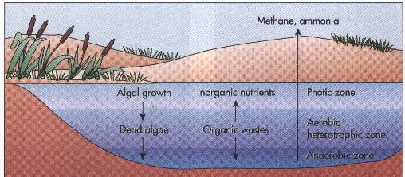

**Figure: Processes involved in Facultative Ponds**



**Figure: Processes involved in Facultative Ponds**

* As can be seen in Figure, facultative ponds have three biologically-active layers. In the bottom, where sludge accumulates, organic matter is degraded anaerobically.
* In the top layer, the organic matter is degraded aerobically due to the presence of dissolved oxygen produced by photosynthesis occurrence in algae. Finally, in the middle layer, the facultative layer, dissolved oxygen is present some of the time, fed from the upper layer.
* The transformations occurring in a facultative pond are generally from biodegradable organic matter to living organic matter (i.e. algae, bacteria, protozoa, etc.). The WHO state that the biochemical oxygen demand generated from living organisms such as algae is not necessarily detrimental to the environment.

1. **Aerobic Ponds (Algae ponds):**

* In aerobic stabilization ponds (also known as *algae* ponds), the oxygen is supplied by natural surface aeration and by algal photosynthesis.
* The pond is kept shallow (0.5 to 1.2 m), so that it functions aerobically throughout the depth. Shallower levels will encourage growth of rooted aquatic plants while greater depth may interfere with mixing and oxygen transfer from the surface.
* Very shallow depth of aerobic pond (of depth 0.15 m to 0.45 m) is used for the treatment of irrigation return water or any other industrial waste where the aim is the removal of nitrogen by algal growth.
* However for the treatment or domestic waste, the depth is kept between 1 to 1.2 m. The length to width ratio of the pond depends on the geometry of the land but should be maximized to approach but not be exceed 3:1.
* This tends to prevent short circuiting. The influent and effluent structures are so located that entire lagoon volume is utilised.
* The contents of the tank are stirred occasionally to prevent anaerobic conditions in the settled sludge. Except for the algal population, the microbiological population present in the ponds are similar to that in activated sludge system.
* The daily flow of sewage containing organic material provides necessary food to the aerobic population which stabilizes the putrescible matter by oxidising it to form nitrates and CO2.
* The algal population use these products for their growth to produce more algal cells and, during daylight, oxygen which is again used by the aerobic population to decompose the original Waste.
* The action taking place in these ponds is known as bacterial – algal – symbiosis. Thus the symbiotic relation between bacteria and algae leads to the stabilization of the incoming waste.

Oxygen transfer in the lagoon depends on the following factors:

1. **Ratio of Lagoon surface area to volume:** Larger the min better will be the oxygen diffusion into the lagoon
2. **Turbulence:** Generally provided by the wave action.
3. **Temperature of lagoon:** Greater solubility of oxygen in water and hence greater diffusion rate at lower temperature.
4. **Bacterial oxygen-up take rate:** The faster the micro-bial population consumes the dissolved oxygen, the greater will be the rate at which oxygen is replenished.

The aerobic decomposition results in the production of carbon dioxide, water and ammonia, as indicated by the following equation

C11H29O7N + 14O2 + H+  11CO2 +13 H2O + NH4+

Several steps in the oxidation process, including the formation of new bacterial cells, in turn oxidize more organic waste. The oxygen is produced by algae in the presence of sunlight and the liquid gets supersaturated with oxygen to an extent of about 20 mg/l. This is consumed by the bacterial community in the night and the nocturnal concentration falls to zero. Oxygen released by photosynthesis to algae is represented by the following relationship:

Sunlight

NH4+ + 7.6 CO2 + 17H2O + 17H2O 15.2 H2O + H+ - 866 Kcal. Per gram + C7H8.1 O2.5 N + 7.6 O2

The composition of biological cell mass is approximated by the formula C120 H180 O45 N15 KP. According to this empirical formula. The basic requirement of bacterial cell growth is nitrogen (N), potassium (K) and phosphorous (P) and hence sufficient quantities of these should be available in the wastewater and if not, they should be added to the wastewater to assure biological oxidation. A good rule of thumb to follow is to maintain a BOD/N/P/K ratio in the lagoon influent of 100/5/1/1.

The expected BOD removal efficiency, which is 80 to 95 percent under normal conditions, decrease during winter months. If pH is a problem, neutralization and equalization may be necessary prior to aerobic lagooning.

Loading may be taken as 150 to 200 kg BOD5 per hectare per day during cold weather. Which may be increased considerably during summer. The detention period should be about 7 days for proper development of algae.

**OXIDATION DITCH:**

* The oxidation ditch, which is essentially an extended aeration activated sludge process, was developed for small towns is Netherlands.
* An oxidation ditch consists of an endless ditch for the aeration tank and a rotor for aeration mechanism.
* The ditch consists of a long continuous channel, usually oval in plan.
* The channel may be earthen with lined sloping sides and lined floor or it may be built in concrete or brick with vertical walls. There is normally no primary tank used in the oxidation ditch process. Raw sewage passes directly through a bar screen to the ditch.
* The sewage is aerated by a surface rotor (generally. a cage rotor) placed across the channel. The rotor entrains the necessary oxygen into the liquid and keeps the contents of the ditch mixed and moving.
* They are designed to impart a velocity or 0.3 to 0.4 m/sec the mixed liquor, preventing the biological sludge from settling out. Cage rotors usually have a dia. of 70 cm (27.5 in.) and a speed of 75 rpm.
* Rotors are manufactured in 30 cm intervals upto 4.5 m length. A rotor assembly can be of multiple lengths but it must be supported by intermediate bearings.
* The selection of rotor assembly length dictates the approximate cross-section of the ditch. The width of the ditch divided by the rotor length should give a ratio between 1.5 and 2.8. The larger ratios are normally used for short length of 0.9 to 1.2 m
* The standard oxygen transfer capacity of rotors is 2.8 kg O2 per m length at 16 cm depth of immersion.
* This rotor has been found to impart adequate circulation for l20 - l50 m3of ditch volume per meter length of rotor. Power requirements per metre length is about 1.35 kW at the rpm and immersion depth stipulated.
* The ends of the ditch are rounded to prevent eddying and dead areas. The depth of ditch is kept as 1.0 to 1.2 m and the length of the ditch is designed to give the required aeration tank volume.
* Oxidation ditches are constructed in two types :

1. Continuous flow type
2. Intermittent flow type.

**Process theory and design considerations:** The oxidation ditch entails a physical and biological process. A small portion of the organic matter undergoes direct chemical oxidation. but the bulk of the organic matter is stabilised by the biochemical activities of the micro-organisms previously formed in the system.

The substrate level or food value of the used water, as measured by the bio-chemical oxygen demand provides proper diet for the micro-organism. The oxidation ditch process, with its long term aeration basin, is designed to carry mixed liquor suspended solids (MLSS) concentration of 3000 to 8000 mg/I. This provides a large organism weight in the system.

The food-to-organism ratio (or loading factor) is low, ranging from 0.03 to 0.1. This low factor produces a system that can absorb loading without upsetting the operation. Also, because of low F/M ratio and because of endogenous respiration the growth of volatile sludge is relatively low. The volatile sludge is less reactive and has a lower BOD than an equivalent weight of sludge produced by the processes having larger loading factors.

The efficiency of oxidation ditch is more than 95% for suspended solids and more than 98% for BOD. The sludge formed in the purification process is mineralised to such an extent that it can be dried without causing any objectionable odours.

For normal domestic sewage, the volume of ditch required under Indian climates should be such as to give a detention period of 12 to 15 hours or 0.8 to 2.5 m3 per kg of BOD5 load present in the sewage admitted. High concentration of suspended solids, about 4000 mg/l, should be kept to obtain the desired BOD loading. The volume of the ditch approximates150 m3 per metre length of the rotor. The oxidation ditches are aeration units in the shape of long channels 150 to 1000 m long. 1 to *5* m wide and l to 1.5 m deep.